Dhruvil Dobariya

dhruvildobariya21@gmail.com

Abstract

In this module I learn basic about DMS controls

DMS Controls

Documentation

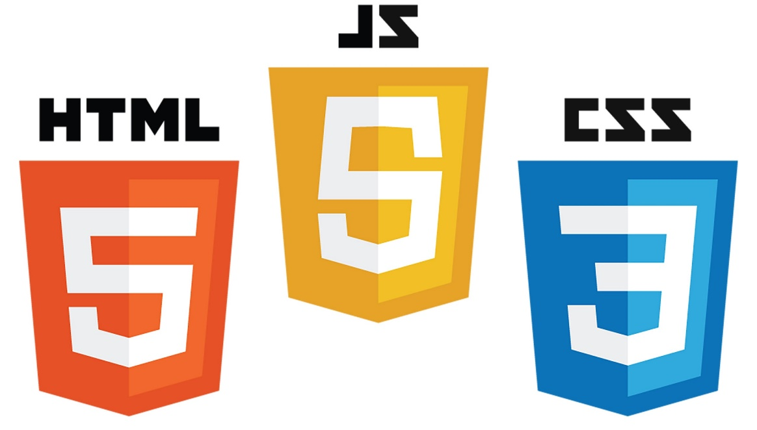

Index

1 Basic Controls 1

1.1 Button 1

1.2 Textbox 2

1.3 Numberbox 2

1.4 Radio Button 3

1.5 Checkbox 4

2 Date Picker 5

2.1 Introduction 5

3 Select Picker 7

3.1 Introduction 7

1. Basic Controls

# Button

**Syntax:**

<form *action*="" *id*="form">

    <button *id*="" *class*="">Click me</button>

*<!-- Or -->*

    <input *type*="button" *value*="">

</form>

**Attributes:**

|  |  |
| --- | --- |
| Attribute | Description |
| Id | set id of button |
| class | set class of button |
| name | set name of button |
| type | set button type, we have three type of button like, button, submit and reset |
| value | set button value, it will only work with input type button |
| autofocus | set focus on page load |
| disabled | set disable button |
| form | specify action, where we want to post data, it will work if form type id submit |
| formaction | specify action, where we want to post data, it will work if form type id submit |
| formenctype | set encoded on form data which we send to the server, we have diffrent option like, application/x-www-form-urlencoded, multipart/form-data, text/plain |
| formmethod | set method of form, we have two type of method, get and post |
| formnovalidation | specify that form should not validate on submitting form, it only work with submit type |
| formtarget | specify where to display response after submitting the button, it will only work with submit type, we have different option like,   * _blank: loads the response in a new window/tab * _self: loads the response in a new window/tab (this is default) * _parent: loads the response in the parent frame * _top: loads the response in the full body of the window * <framename>: loads the response in a named iframe |

# Textbox

**Syntax:**

<form *action*="">

    <input *type*="text" *name*="city" *id*="" *class*="" *value*="" *placeholder*="" />

</form>

**Attributes:**

|  |  |
| --- | --- |
| Attribute | Description |
| Id | set id of button |
| class | set class of button |
| name | set name of button |
| type | set button type, we have three type of button like, button, submit and reset |
| value | set button value, it will only work with input type button |
| autofocus | set focus on page load |
| disabled | set disable button |
| dirname | set when form is submit direction of input is also include in data, ex: city=Los Angeles&city.dir=ltr |
| list | set id of data list which help in suggestions |
| required | set field is required |
| minlength | set minimum character which user must input |
| maxlength | set maximum character which user must input |
| form | specify action, where we want to post data, it will work if form type id submit |
| formnovalidation | specify that form should not validate on submitting form, it only work with submit type |

# Numberbox

**Syntax:**

<form *action*="">

    <input *type*="number" *name*="city" *id*="" *class*="" *value*="" *placeholder*="" />

</form>

**Attributes:**

|  |  |
| --- | --- |
| Attribute | Description |
| Id | set id of button |
| class | set class of button |
| name | set name of button |
| type | set button type, we have three type of button like, button, submit and reset |
| value | set button value, it will only work with input type button |
| autofocus | set focus on page load |
| disabled | set disable button |
| dirname | set when form is submit direction of input is also include in data, ex: city=Los Angeles&city.dir=ltr |
| list | set id of data list which help in suggestions |
| required | set field is required |
| min | set minimum value of input |
| max | set maximum value of input |
| step | set step for input |
| form | specify action, where we want to post data, it will work if form type id submit |
| formnovalidation | specify that form should not validate on submitting form, it only work with submit type |

# Radio Button

**Syntax:**

<form *action*="">

    <input *type*="radio" *name*="gender" *id*="male" *class*="" *value*="male" />

    <label *for*="male">Male</label>

    <input *type*="radio" *name*="gender" *id*="female" *class*="" *value*="female" />

    <label *for*="female">Female</label>

</form>

**Attributes:**

|  |  |
| --- | --- |
| Attribute | Description |
| Id | set id of button |
| class | set class of button |
| name | set name of button |
| type | set button type, we have three type of button like, button, submit and reset |
| value | set button value, it will only work with input type button |
| autofocus | set focus on page load |
| disabled | set disable button |
| checked | checked radio button |
| form | specify action, where we want to post data, it will work if form type id submit |
| formnovalidation | specify that form should not validate on submitting form, it only work with submit type |

# Checkbox

**Syntax:**

<form *action*="">

    <input *type*="checkbox" *name*="hobbies" *id*="playingCricket" *class*="" *value*="Playing Cricket" />

    <label *for*="playingCricket">Playing Cricket</label>

    <input *type*="checkbox" *name*="hobbies" *id*="playingFootball" *class*="" *value*="Playing Football" />

    <label *for*="playingFootball">Playing Football</label>

    <input *type*="checkbox" *name*="hobbies" *id*="playingChess" *class*="" *value*="Playing Chess" />

    <label *for*="playingChess">Playing Chess</label>

    <input *type*="checkbox" *name*="hobbies" *id*="readingBook" *class*="" *value*="Reading Book" />

    <label *for*="readingBook">Reading Book</label>

</form>

**Attributes:**

|  |  |
| --- | --- |
| Attribute | Description |
| Id | set id of button |
| class | set class of button |
| name | set name of button |
| type | set button type, we have three type of button like, button, submit and reset |
| value | set button value, it will only work with input type button |
| autofocus | set focus on page load |
| disabled | set disable button |
| checked | checked checkbox |
| form | specify action, where we want to post data, it will work if form type id submit |
| formnovalidation | specify that form should not validate on submitting form, it only work with submit type |

1. Date Picker

# Introduction

* It is provide by jQuery.
* So when we use datepicker we must first include jQuery then we must include jQuery ui.

**Example:**

<!DOCTYPE *html*>

<html *lang*="en">

    <head>

        <meta *charset*="UTF-8" />

        <meta *http-equiv*="X-UA-Compatible" *content*="IE=edge" />

        <meta *name*="viewport" *content*="width=device-width, initial-scale=1.0" />

        <title>Document</title>

        <link *rel*="stylesheet" *href*="../../assets/lib/jquery-ui-1.13.2/jquery-ui.min.css" />

    </head>

    <body>

        <div>

            <input *type*="text" *id*="datepicker" />

        </div>

        <script *src*="../../assets/lib/jQuery/jquery-3.6.3.min.js"></script>

        <script *src*="../../assets/lib/jquery-ui-1.13.2/jquery-ui.min.js"></script>

<script>

            $(document).ready(*function* () {

                $("#datepicker").datepicker();

            });

        </script>

    </body>

</html>

**Options:**

|  |  |
| --- | --- |
| Attribute | Description |
| selectOtherMonths | enable to select date of before or after month in current mount menu |
| showButtonPanel | Display button bar |
| changeMonth | Display month menu |
| changeYear | Display year menu |
| numberOfMonths | Display multiple month |
| showOn | Show button, when we click it, datepicker will open |
| buttonImage | Set button image |
| buttonImageOnly | Set button is image only or not in boolean |
| buttonText | Set button text |
| minDate | Set minimum date |
| maxDate | Set maximum date |
| showWeek | Show number of week of year |
| firstDay | Set first day of month |
| dateFormat | Set date format |
| showAnim | Set animation, we have many animation options like, show, slideDown, fadeIn, blind, bounce, clip, drop, fold, slide |

1. Select Picker

# Introduction

* Select Picket provides by bootstrap.
* So, we must first include bootstrap after we should include selectpicker.

**Example:**

<!DOCTYPE *html*>

<html *lang*="en">

    <head>

        <meta *charset*="UTF-8" />

        <meta *http-equiv*="X-UA-Compatible" *content*="IE=edge" />

        <meta *name*="viewport" *content*="width=device-width, initial-scale=1.0" />

        <title>Document</title>

        <link *rel*="stylesheet" *href*="https://cdn.jsdelivr.net/npm/bootstrap@4.6.2/dist/css/bootstrap.min.css" *integrity*="sha384-xOolHFLEh07PJGoPkLv1IbcEPTNtaed2xpHsD9ESMhqIYd0nLMwNLD69Npy4HI+N" *crossorigin*="anonymous" />

        <link *rel*="stylesheet" *href*="../../../assets/lib/bootstrap-select-1.13.14/dist/css/bootstrap-select.min.css" />

        <link *rel*="stylesheet" *href*="https://cdn.jsdelivr.net/npm/bootstrap-icons@1.10.2/font/bootstrap-icons.css" *integrity*="sha384-b6lVK+yci+bfDmaY1u0zE8YYJt0TZxLEAFyYSLHId4xoVvsrQu3INevFKo+Xir8e" *crossorigin*="anonymous" />

    </head>

    <body>

        <div *class*="mt-3">

            <select *name*="" *id*="select" *title*="Select City" *multiple*>

                <option *value*="1">Channai</option>

                <option *value*="2">Ahmedabad</option>

                <option *value*="3">Bangalore</option>

                <option *value*="4">Los Angeles</option>

                <option *value*="5">New York</option>

                <option *value*="6">Las Vegas</option>

                <option *value*="7">City of Miami</option>

            </select>

        </div>

        <div *class*="mt-3 ml-3">

            <button *class*="btn btn-danger" *id*="hide">Hide</button>

            <button *class*="btn btn-success" *id*="show">Show</button>

        </div>

        <script *src*="../../../assets/lib/jQuery/jquery-3.6.3.min.js"></script>

        <script *src*="https://cdn.jsdelivr.net/npm/bootstrap@4.6.2/dist/js/bootstrap.bundle.min.js" *integrity*="sha384-Fy6S3B9q64WdZWQUiU+q4/2Lc9npb8tCaSX9FK7E8HnRr0Jz8D6OP9dO5Vg3Q9ct" *crossorigin*="anonymous"></script>

        <script *src*="../../../assets/lib/bootstrap-select-1.13.14/dist/js/bootstrap-select.min.js"></script>

        <script>

            $(document).ready(*function* () {

                $("#select").selectpicker();

            });

        </script>

    </body>

</html>

**Options:**

|  |  |
| --- | --- |
| Attribute | Description |
| actionsBox | set selectAll and deselectAll button |
| countSelectedText | set format of count |
| deselectAllText | deselect all selected item when dropdown rendered |
| dropdownAlignRight | set all the option align right side, we also have one more option which is "auto" |
| dropupAuto | first it check upper or lower side have enough space or not, if have then it open normally else it open in dropup |
| header | set header of dropdown |
| hideDisabled | remove all element which is disable, also remove disable groups |
| iconBase | set icon base |
| liveSearch | set live search |
| liveSearchNormalize | set accent-insensitive search |
| liveSearchPlaceholder | set placeholder in search box |
| liveSearchStyle | set search style, We have two options like, When set to 'contains', searching will reveal options that contain the searched text. For example, searching for pl with return both Apple, Plum, and Plantain. When set to 'startsWith', searching for pl will return only Plum and Plantain. |
| maxOptions | set max number of selection |
| mobile | set mobile view |
| multipleSeparator | set seperator between multiple |
| noneSelectedText | The text that is displayed when a multiple select has no selected options, it show it's output when we don't give title to dropdown |
| selectedTextFormat | set display format, we have many options like,   * value: give comma seperated value * count: give count of selected value * count > 2: give value until condition become true, after it give count * static: always so placeholder |
| selectAllText | show text when we select all the option of dropdown |
| selectOnTab | treat tab like enter or space character in dropdown |
| showContent | enable render content inside dropdown elements |
| showIcon | enable to render icon in dropdown options |
| showSubtext | enable to render subtext in dropdown options |
| showTick | enable to render tick on selected options |
| size | set how many element show in window when window is open, if dropdown have more window then it enable scrollbar in window |
| style | set style |
| styleBase | set base style |
| tickIcon | set which icon we want to use as tick |
| title | set title of dropdown |
| width | set width, we have different option like, auto, fit, 100%, 100px |
| windowPadding | set padding in widow, we also can pass array like [10, 20, 20, 40] which represent [top, right, bottom, left] |
| sanitize | set sanitize, which sanitize data-content of options |
| whiteList | set whishList, it take object which contains allow attributes and tags |
| sanitizeFn | set sanitize function, it is used for dedicated library which use to parform sanitization. |

**Methods:**

|  |  |
| --- | --- |
| Attribute | Description |
| val | select one or more based on value |
| render | It will render the selectpicker |
| refresh | It will refresh the selectpicker |
| selectAll | it will select all options |
| deselectAll | it will deselect all options |
| mobile | enable mobile |
| setStyle | set button style |
| toggle | open/close dropdown |
| hide | hide dropdown |
| show | show dropdown |
| destroy | destroy dropdown |

**Events:**

|  |  |
| --- | --- |
| Attribute | Description |
| show.bs.select | immediately triggered when dropdown show event start |
| shown.bs.select | triggered when dropdown show event end |
| hide.bs.select | immediately triggered when dropdown hide event start |
| hiddem.bs.select | triggered when dropdown hide event end |
| refresh.bs.select | triggered after dropdown is refresh |
| rendered.bs.select | triggered after dropdown is rendered |
| loaded.bs.select | triggered after select has been initialized |
| changed.bs.select | triggered after select value is changed |